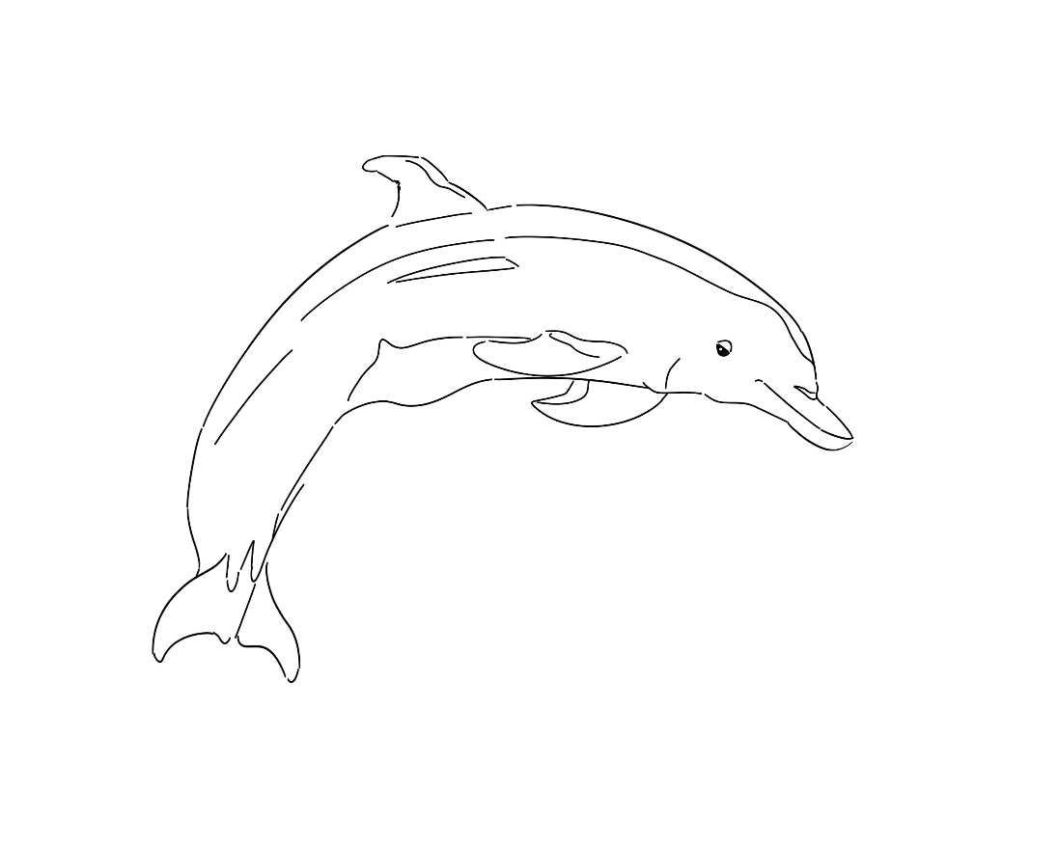
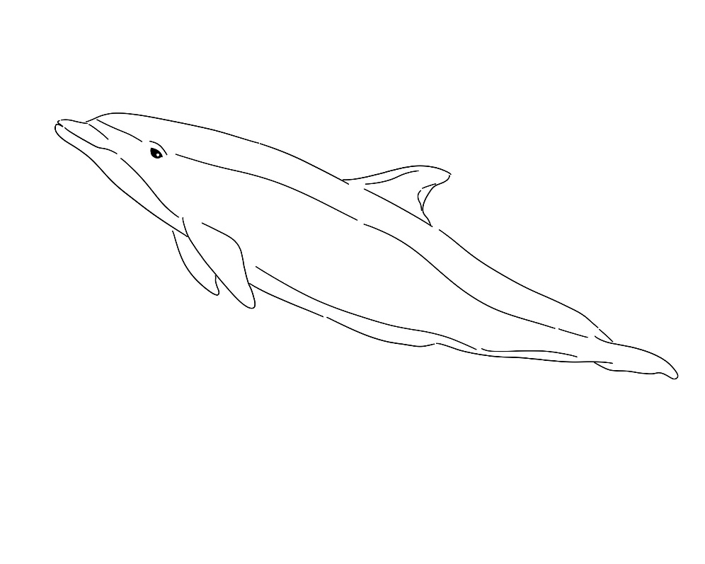
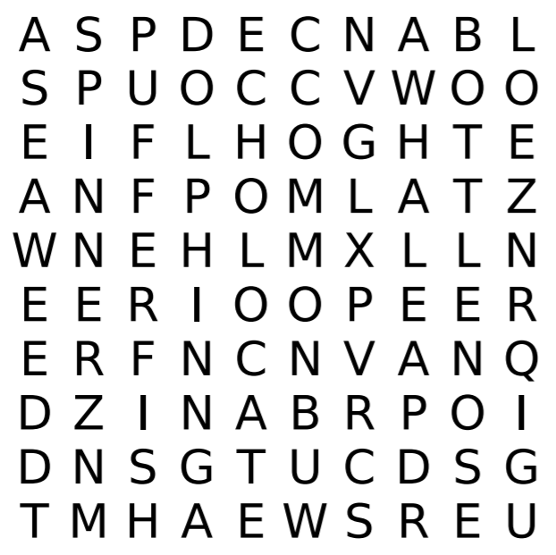
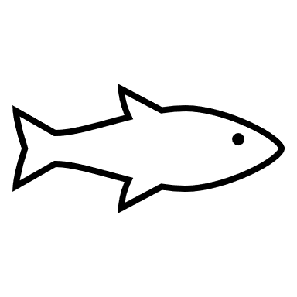
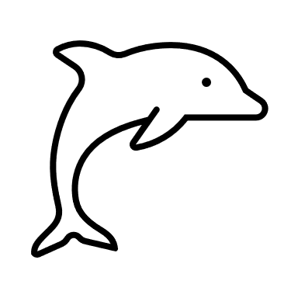

Art by Judy Ann Hallmark (’21)
Dolphins!
Word Bank:
dolphin
echolocate
pufferfish
seaweed
common
bottlenose
spinner
whale
Help the dolphin echolocate and find its fishy snack!

